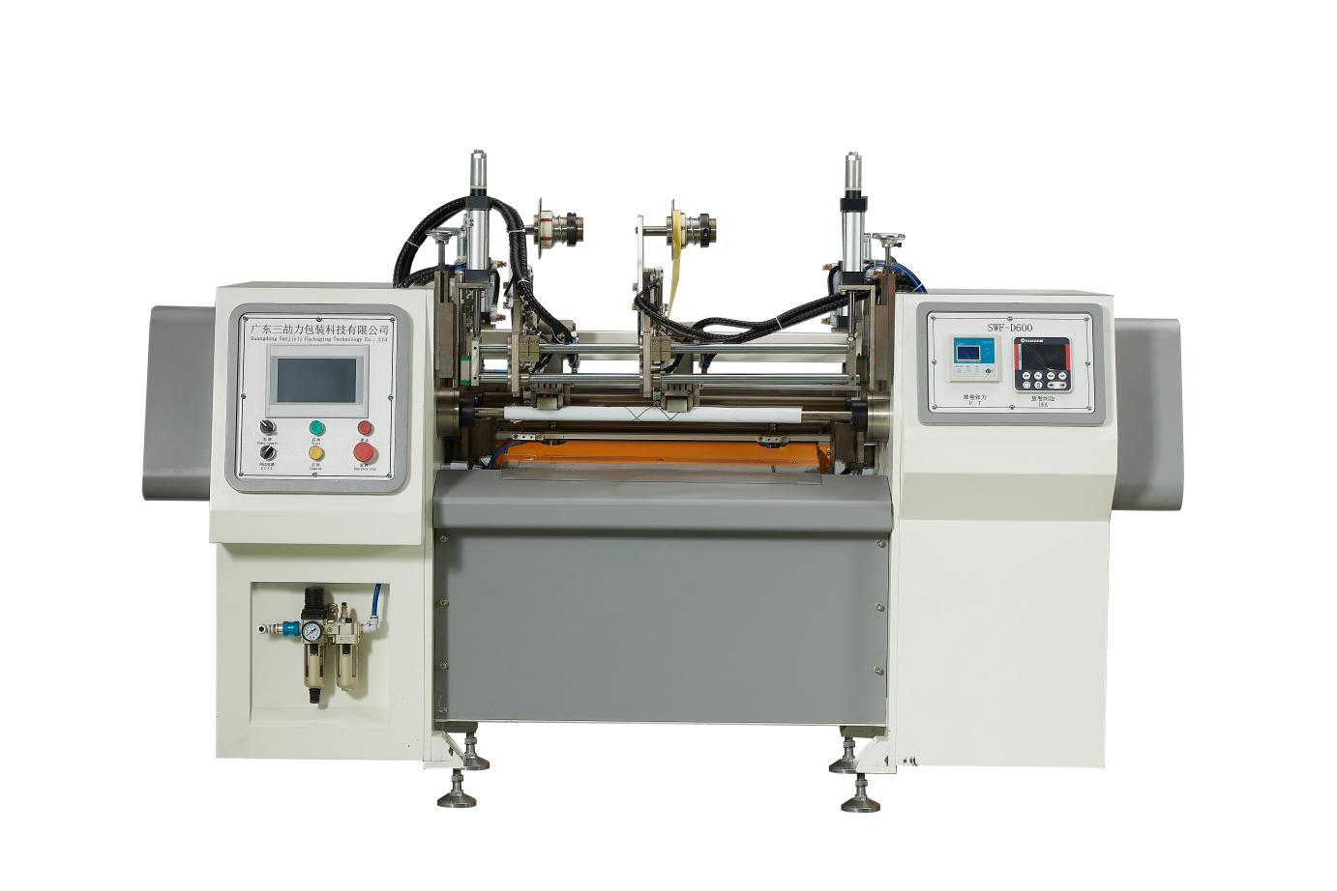
Fully Automatic Glue-Free Coreless Rewinder ZRF-D600
Plan sketch：
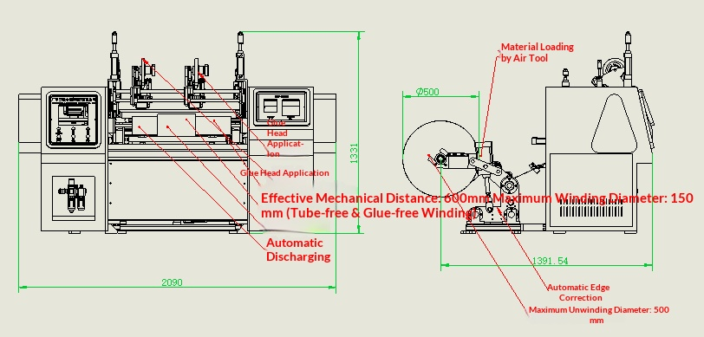
Basic Use：
It is mainly used for glue-free rewinding of materials such as kraft paper, wallpaper and automotive films, etc.

Product characteristics：
- Hokawa motion control system, servo control for winding, servo control for active traction.
- The automatic cylinder feeding system is adopted, which is convenient, fast and labor-saving.
- Automatic tension winding and unwinding, with stable tension and smooth start/stop; servo motor torque winding, with stable and precise tension, exquisite winding quality, and flat end surfaces.
- Without core insertion, the end is automatically sealed with adhesive tape, and the control system is from Hokkaido. Thus, the automatic and seamless re-rolling function without adhesive and without core is achieved.
- Action characteristics: Cut after clamping, attach tail label, retract and contract to unload, complete one action and then deliver the material for the next feeding, then the roll extends to clamp the material, the roll is a clamping type roll, achieving continuous and effective operation.

Main technical parameters：
Model | SWF-D600
paper core | Collecting the answers
Unwinding master roll | 500mm  Max. Unwind Roll Diameter 500mm
Rewinding diameter | 20-150mm
Rewind width | W（0-600）mm
Production speed | Mechanical Line Speed 120m/min
power supply | 220V 50/60HZ4KW
air pressure | 5KG
Machine size | 2100*1500*1400mm
Net Weight | 800KG

Configuration parameters：
Model | SWF-D600
Touch screen | 7-inch MCGS HMI
Rack wall panel | 36mm
Movement controller | HCFA
Active traction servo motor | HCFA
Active traction servo driver | HCFA
Receiving roll servo motor | HCFA
Rolling shutter servo driver | HCFA
Solenoid valve | ASICKO
Cylinder | AIRTAC
Linear slide | HIWIN
Magnetic switch | AIRTAC
Unroll 3-inch air expansion shaft | Taiwan,China
bearing | NSK
Traction shaft | Precision grinding roller
Compression roller | Silicone package
Transitional roller | European standard aluminum guide wheels

